NOTES: ________________________________________________________________________________________________________________________________________________________________________________________________________________________________________________________________________________________________________________________________________________________________________________________________________________________________________________________________________________________________________________________________________________________________________________________________________________________________________________________________________________________________________________________________________________________________________________________________________________________________________________________________________________________________________________________________________________________________________________________________________________________________________________________________________________________________________________________________________________________________________________________________________________________________________________________________________________________________________________________________________________________________________________________________________________________________________________________________________________________________________________________________________________________________________________________________________________________
Robert Wiesner, Pastor
Telephone: 716.875.6223
Email: info@kenmorebaptistchurch.com

www.kenmorebaptistchurch.com

“Living Together For The King!

Kenmore Baptist Church

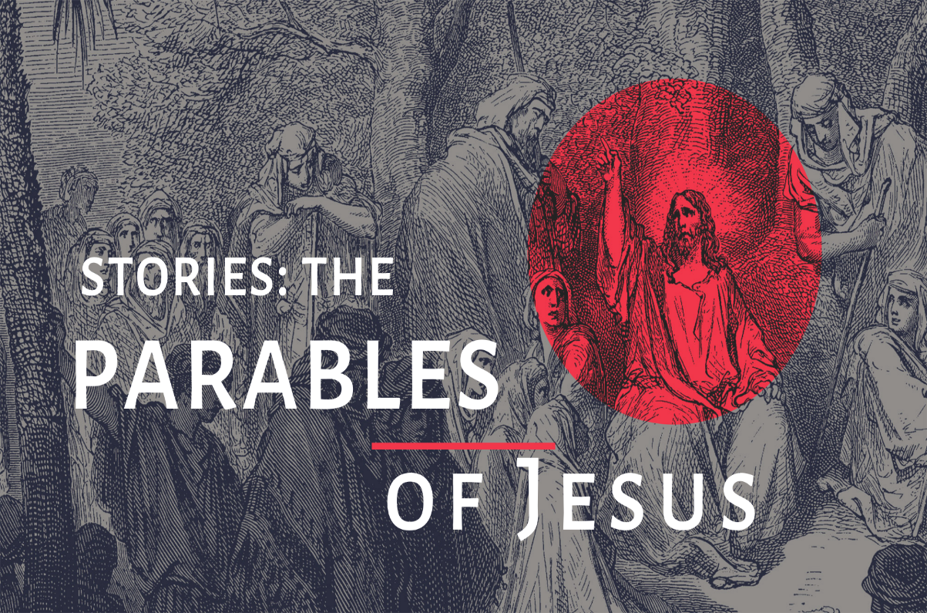
July 19, 2020

March 7, 2021

ORDER OF WORSHIP

1. Call to Worship

2. Nothing but the Blood
Waiting Here for You

3. Announcements

4. Reckless Love

5. Scripture Reading

6. Pastoral Prayer

7. Sermon: Why Parables?
Mark 4:11-12

8. Let the Redeemed

9 . Benediction

Let’s give special attention in the form of calls or cards to:
June Morey
157 Wellington
Buffalo NY 14223

ANNOUNCEMENTS

New to KBC? If you're new to KBC we're glad you're here! We would love to get connected, pray for you, and learn how we might serve you. Please connect with us by sending an email to info@kenmorebaptistchurch.com and our pastor will reply."

There will be a box available in the foyer for your tithes and offerings to be dropped off. Also, you are welcome to give on the web site via Pay Pal, or contact Bonnie Tordy to set up monthly credit card giving.

If you believe you are at higher risk or may have come in contact with Covid19, please join us for worship via live stream at www.facebook.com/kenmorebaptistchurchwny/ every Sunday at 11:00 AM.
Changes Due to COVID-19, we will not be taking ordering flower for the sanctuary. We would like to still have the option to Memorialize or Honor a Loved one this Lenten Season. We will recognize them in the Easter Sunday Bulletin as well as in the April Compass. Please submit your donation and the information for the gift to Bonnie Tordy in the office. Note the donation: Remembrance Gift

