NOTES: ________________________________________________________________________________________________________________________________________________________________________________________________________________________________________________________________________________________________________________________________________________________________________________________________________________________________________________________________________________________________________________________________________________________________________________________________________________________________________________________________________________________________________________________________________________________________________________________________________________________________________________________________________________________________________________________________________________________________________________________________________________________________________________________________________________________________________________________________________________________________________________________________________________________________________________________________________________________________________________________________________________________________________________________________________________________________________________________________________________________________________________________________________________________________________________________________________________________
Robert Wiesner, Pastor
Telephone: 716.875.6223
Email: info@kenmorebaptistchurch.com

www.kenmorebaptistchurch.com

“Living Together For The King!

Kenmore Baptist Church

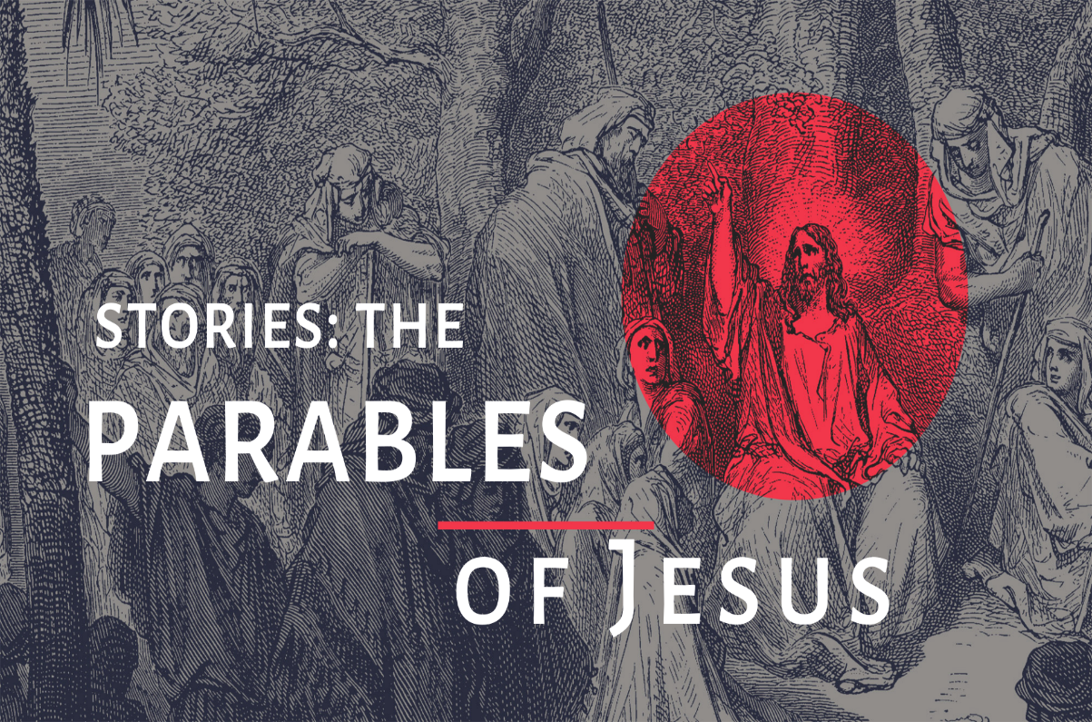
July 19, 2020

March 21, 2021

ORDER OF WORSHIP

1. Call to Worship

2. Jesus
I want to know You

3. Announcements

4. Here Again

5. Scripture Reading

6. Pastoral Prayer

7. Sermon: The Invitation
Luke 14:16-21

8. We give You Glory

9 . Benediction

ANNOUNCEMENTS

New to KBC? If you're new to KBC we're glad you're here! We would love to get connected, pray for you, and learn how we might serve you. Please connect with us by sending an email to info@kenmorebaptistchurch.com and our pastor will reply."

There will be a box available in the foyer for your tithes and offerings to be dropped off. Also, you are welcome to give on the web site via Pay Pal, or contact Bonnie Tordy to set up monthly credit card giving.
Changes Due to COVID-19, we will not be taking ordering flower for the sanctuary. We would like to still have the option to Memorialize or Honor a Loved one this Lenten Season. We will recognize them in the Easter Sunday Bulletin as well as in the April Compass. Please submit your donation and the information for the gift to Bonnie Tordy in the office. Note the donation: Remembrance Gift
Please join us for a drive-by baby shower honoring Jennifer and Emmanuel on: Saturday, March 27th 11:30-12:30
in the Kenmore Baptist church parking lot
Let's shower the parents to be with cards and gifts to let them know we care and wish we could be there.
They are registered at Target under the name Jennifer Muhawe if you would like some gift ideas. Here is the link: https://www.target.com/gift-registry/giftgiver?registryId=f292b3d39c1249d984561c49809431e1&type=BABY
If you prefer, gifts can be dropped off at Barb Gamble's home prior to the shower and we will make sure they are forwarded.
This is the Meal Train for Jennifer & Emmanuel :
https://mealtrain.com/0o9wz3
What is a meal train?
There are times in our lives when friends and family ask, "What can I do to help out?" The answer is usually to help them with a meal. With this link: we can easily Coordinate a calendar of meals!

